Environmental Modelling & Forecasting Workshop
The Alan Turing Institute – Wednesday 14th January 2026 – SPHERE-PPL
info@sphere-ppl.org

Agenda
Timings | Activity | Description
9:30-10:00 | Arrivals & Registration
10:00-10:15 | Introduction from the SPHERE-PPL Team - Will Pearse | Meet the team and an introduction to the vision
10:15-10:40 | Keynote 1 - Julie Smith | ADAS
10:40-11:00 | Keynote 2 - Robin Freeman | ZSL
11:00-11:25 | Coffee Break
11:25-11:35 | Presentation - Rich Wood | Forecasing Severe System Pressure in the NHS
11:35-12:20 | Break-Out Discussion | Activity 1 - Identifying key challenges in environmental science
12:20-12:50 | Break-Out Feedback | 2-minute presentations on challenges
12:50-13:50 | Lunch
13:50-14:00 | Lyme Disease Contest Prize Giving
14:00-14:10 | Presentation - Will Pearse | Building a Forecasting Contest
14:10-14:45 | Break-Out Design | Activity 2 - Groups design forecasting contests
14:45-15:15 | Break-Out Feedback | Group feedback and discussion of contest priorities
15:15-15:40 | Coffee Break
15:40-16:05 | Keynote 3 - Eric Daub | The Alan Turing Institute
16:05-16:15 | Presentation - Will Pearse | What can SPHERE-PPL do for you?
16:15-16:35 | Break-Out Discussion | Activity 3 - Brainstorming requests for workshops, training and support
16:35-16:55 | Break-Out Feedback | Creating a community priority list
16:55-17:00 | Wrap-Up

WiFi
Network: Turing Guest
Password: clicking seventh void compiled (Password contains spaces)
Eduroam is also available

Resources
Event Page: https://sphere-ppl.org/Annual-Meeting-Jan26/
Mural Board: https://shorturl.at/carOR or follow the link on the Event Page

Facilities
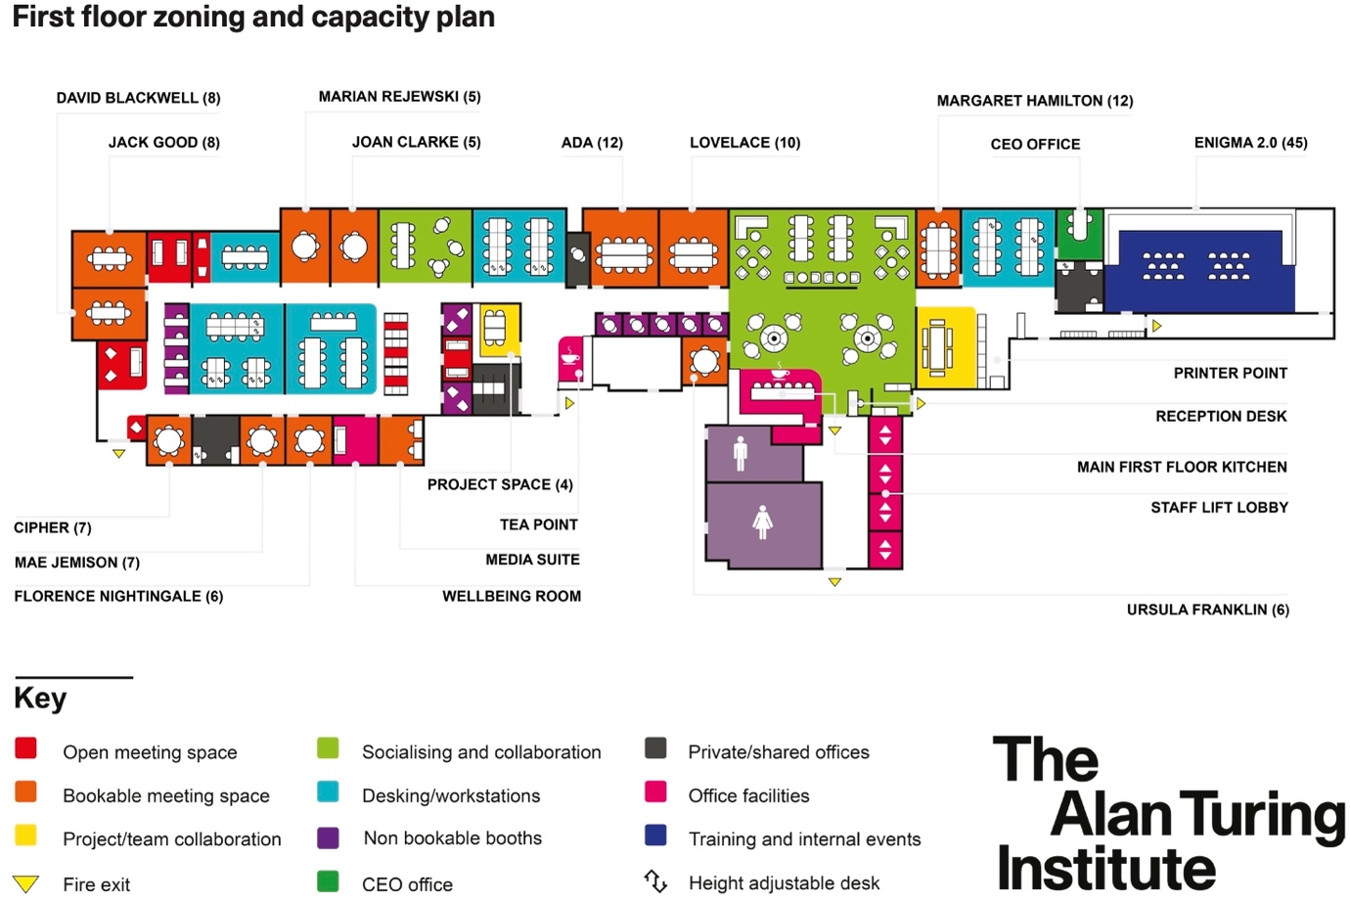

Code Of Conduct
- Respectful Communication: Communicate with others in a professional and considerate manner. Be mindful of diverse perspectives and experiences. Avoid interrupting others and listen actively.
- Inclusive Language: Use inclusive language that avoids any discriminatory or offensive remarks. Be mindful of gender, race, ethnicity, religion, sexual orientation, and other personal attributes.
- Active Participation: Engage actively in discussions and activities. Share your insights and perspectives while being mindful of others' contributions.
- Professional Conduct: Maintain a professional demeanour throughout the workshop, including during breaks and social events.
- Mobile Devices: Minimize distractions by silencing mobile phones or using them only during breaks, unless they are essential for workshop activities.

